Meet the Committee

Vicky Axe, Chair (Former Pupil: 1988 – 2001)
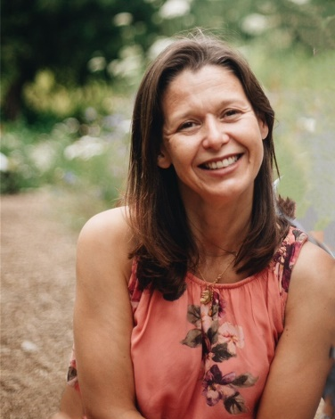
I am a Programme Manager for the National Institute of Health and Care Excellence (NICE). I help develop and publish national evidence-based guidelines which cover a range of topics, from preventing and managing specific health conditions to planning broader services and interventions to improve the health of communities.
Before NICE I worked in Australia for the National Government in Payroll. I have lived and worked in Canberra, Australia and Aix-en-Provence, France. I went to the University of Hull studying English and History.
I have so many wonderful memories of the School. It’s where I was educated from 4 to 18 years old. It’s where my Mum taught, where my Dad worked and where we all lived for a period of time when they were Boarding House parents. It’s where I got married, where my children were christened and where they now go to school. I made so many special friends at the school that I still regularly see.

Although I always knew, it is only since having my own children, and especially since COVID, that I have realised just how wonderful each and every teacher at the school was. I loved the PE lessons – it’s quite impressive when you remember how little equipment we had, but yet, how often we would win things, and what a wide range of sports we had access to. I loved the lunches, the play time and the sports clubs. I loved the bun of the day. I loved the reverence we all held for the black door, the sixth form common room, Mrs Storey’s office and the staff room! Even though so much has changed at the school, it still has that family feel. You still drive down that beautiful driveway, and when I walk into the chapel or the school hall, I still remember being there and all the people I was there with. It was a special, happy time and it’s lovely to see the new generations enjoying it just as much as I did.

Margaret Hope (Hurn), Vice Chair (Former Pupil: 1958 – 1971)
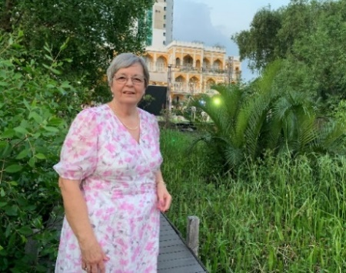
I attended Westwood House as it was then from 1958 to 1971. I enjoyed school so trying to pick out a favourite memory is difficult, but anything to do with Home Economics would be high on my list. When I left school, I did a HND in Catering Management at Elizabeth College of Higher Education in Manchester then worked for 4 years at Cheshire College of Agriculture as Assistant Domestic Bursar.

I got married in 1978 to Frank and we returned to Thorney where we have lived since then. I then lectured in Catering at the Isle College Wisbech until we had our son John in 1991. Since then, I have done a variety of volunteering roles, at present I’m at the cathedral were I’m part of the embroidery volunteers, where we are stitching a replica of the nave ceiling.
I have been on the Committee for a number of years undertaking various roles, the Treasurer, The Chair and Vice Chair.

Angela Axe (Former Pupil 1953 – 1964)
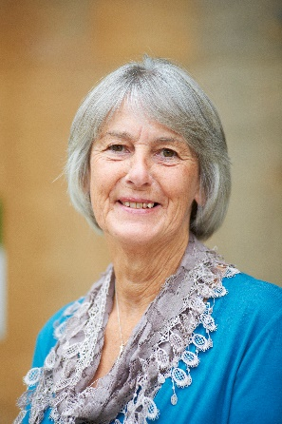
The School has been part of my life for most of my life as I understand I accompanied my elder brother and sister up the drive from 1953. I then joined the School in P1 in 1960, with Miss Wellington as my Form Mistress. I left in 1964 to return as Head of PE in January 1979, taking up the post after Mrs May left to have her baby. I enjoyed teaching PE full time for many years, with so many fond memories of both my colleagues and pupils, including wonderful ski trips, activity holidays and team tours to South Africa and Barbados.

My daughter was a pupil from 1987 - 2001. I also enjoyed 5 years with Mr Axe, as Boarding House parents. Following several years as Head of Pastoral Care I retired from teaching in July 2014, but have had the good fortune to be able to return regularly as a grandparent.

Hannah Baker (Former Pupil: 1992 -2006)
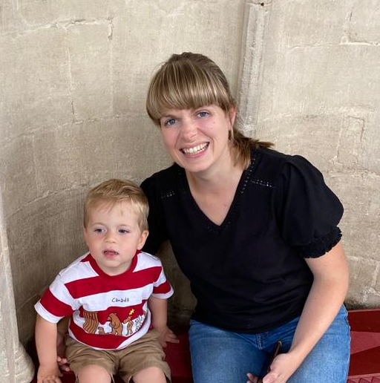
I was at Peterborough High School from 1992 to 2006 and left to study Physiotherapy. After graduation I was a physiotherapist in the NHS and private practice. In 2013 I returned to University to study Agriculture and returned to the area to help run our family business. We have since diversified into holiday lets as well as our arable enterprise. Away from the farm, I enjoy tennis and family life with my husband Rob and young son Joshua and more recently helping run a local community interest company, Coffee Ark.

Gwen Biddle-Edwards (Former Pupil 1947 – 1957)
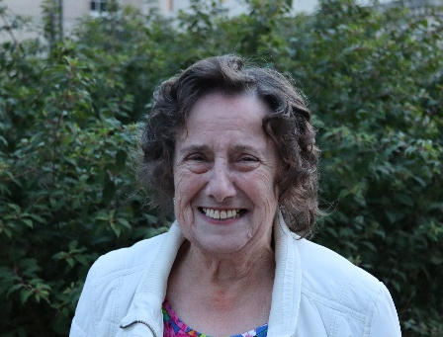
I was educated at Westwood House School from the age of 6 in 1947 to 16 years of age in 1957. On leaving School I was able to secure a position with the TSB, Trustees Savings Bank, in Cumbergate, Peterborough in 1958 and was employed with them until 1991 when I retired. I then however became the Secretary of the Lloyds TSB retirement club and have been doing this for the last 32 years.

I have two daughters, four grandchildren and six great grandchildren. As a hobby my late husband and I, in 1974, started breeding, exhibiting, and judging the British Bulldog, I have judged in England and on the continent many times.

I believe I may be the oldest member of the Westwoodians’ Association Committee and look forward to many more years yet.

Micheala Drazek (Former Pupil: 2006 – 2013)
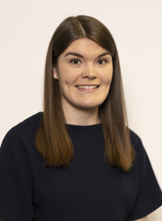
After completing my law degree at the University of Leicester, I started working part time at Greenwoods Legal in Peterborough. On the days I wasn't working I continued to study for my postgraduate diploma in legal practice, and then my masters. Once I was finally done with studying in 2019 (6 years after leaving School!) I began my period of formal training to become a solicitor. I stayed with Greenwoods on qualification and now enjoy advising businesses on all aspects of Employment law. My favourite thing about being a solicitor is building relationships with clients and finding out about the different industries they operate in.

My favourite memories of School are food based! I loved the variety of lunches we had (especially the themed days like celebrating Chinese New Year) and the amazing buns each break time. I had fun singing in the choirs with my friends, especially at Christmas. I also enjoyed studying for my A Levels, while finding any excuse I could to avoid Sixth Form PE on a Friday afternoon!

Hannah Garford
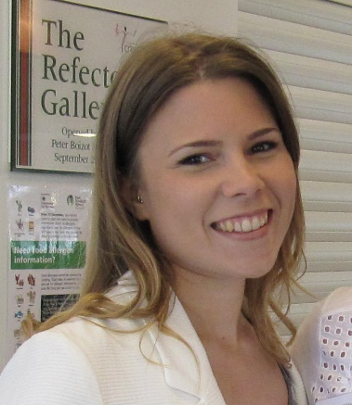
After leaving PHS, I studied History and Sociology at the University of Liverpool and later trained to become a primary school teacher. I love working with children and now have two boys of my own: Max, five and Freddie, two. Life is hectic but so much fun and never a dull moment…!
I have so many happy memories of my time at PHS that it is hard to pick out any in particular. Many involve choir concerts, musical rehearsals or sports matches (even the ones in the rain and snow!). I have been a member of the Westwoodians’ Association Committee since 2007, which has been a great way to keep in touch and see how the school has developed over the years.

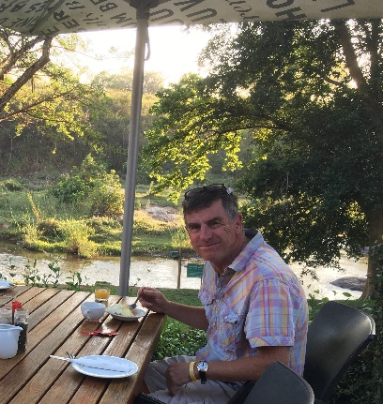
Chris King (Former Staff: 2000 – 2019)
I joined PHS in September 2000 and retired in December 2019. I taught Mathematics in the Senior School and in the latter part of my time at the School was Head of Department. During my time at the School, I was also Head of PSHE, Houses and helped with football and running.
I am now living in Sheringham, where I am Station Master at the Sheringham North Norfolk Railway Station and still enjoy running and playing football.

Julia Lamb (Former Pupil: 1976-1983)
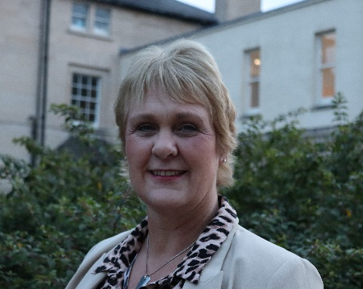
I attended Westwood House from 1976 to 1983. I have 2 sons and 2 grandchildren who live locally.
I have remained in the area, and I am still actively involved in music, teaching piano, and singing to diploma level and travelling Northamptonshire, Lincolnshire, and Rutland as a church organist.

Gillian Mason (Former Staff: 2007-2023)
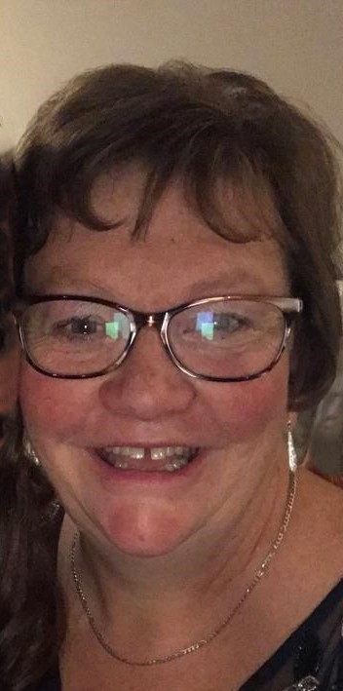
I was initially employed in April 2007 for three afternoons a week, to teach Year 7, 8 and 9 students – an all-girls school at that time and no more than 8 girls, for the whole afternoon, plus help from the Food Technician called Mrs. Tobin. Cooking skills were practiced and perfected. The food technology room housed a separate cooking and teaching area and was bright orange! I imagine a lot of you reading this will remember the orange cupboard doors, a real 70’s flashback.
Big changes occurred over the next few years as I took on full-time teaching, the introduction of boys and a name change to The Peterborough School plus the retirement of Miss Facy. The Food Technology department continued to teach important life skills and in 2017 we introduced the GCSE Food Preparation and Nutrition course.
Also, around this time the Preparatory School curriculum changed to include Cooking for the Year 6 and Lower School pupils and the Food Technology room seemed to be busy all day!!!
It has been such a delight to witness the progress of so many pupils, growing in both ability and confidence, and in turn, producing many amazing dishes and products. I retired from my teaching position to be a grandma and I wanted to be able to spend time with my family. However, as the Headmaster calls it, the ‘’boomerang effect’ happened!! I am now a relief teacher at School, so still have the pleasure of seeing both pupils and staff and retaining all the friendships I have made in 16 happy and fulfilling years.

Gemima Snowden (Former Pupil: 2000 – 2008)
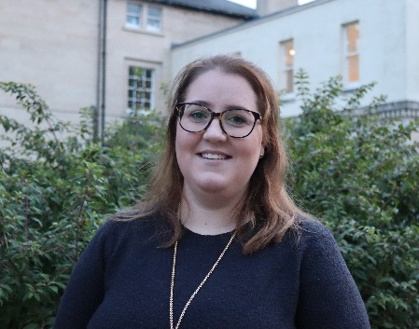
After leaving PHS in 2008, I spent a year travelling to several destinations including Australia, New Zealand, and Fiji. My favourite destination however was Tanzania. Here I spent 3 months teaching in a primary school as well as volunteering with the adult English programme. After this I went on to study Primary Education, with a specialism in Art, at Winchester University before accepting a teaching role at All Saints Primary School in Peterborough. I spent the next 10 years teaching in Years 2 - 5, becoming Phase Leader and a member of the Senior Leadership Team. It was at this time I had my first child, Teddy, so decided to take a break from teaching. Not long after Teddy was born, we were married and then welcomed Hattie into the world. Now I get to enjoy my other passion of animals alongside my farmer husband. We currently breed sheep and cows on our farm near Elton.

My favourite memory of my time at school was the opportunity to travel to South Africa on a netball and Hockey tour - 33 pupils and 3 teachers! It was an incredible experience, and I will never forget being sent on a coastal hike (to waste some time) whilst our GCSE results were faxed over and handwritten onto small individual scraps of paper so we could find out how we did on GCSE results day!

Rosalyn Mayle (Teacher, 1989 to current day)
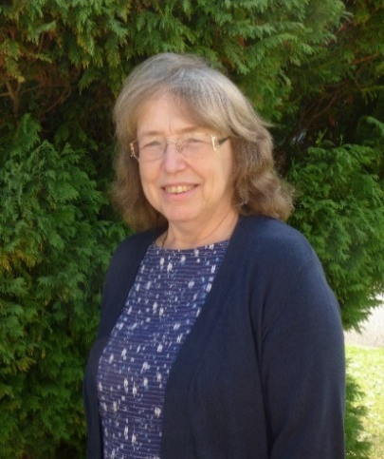
I started working at Westwood House School in September 1989, taking up the position of Head of Geography. During the following years, I was also responsible for the teaching of Travel and Tourism in the Sixth Form. For many years I was the principal Year 7 Form Tutor and, in this role, taught Geography in Year 6 and Reasoning in Years 4,5 and 6. Doing a lot of work on transition into the Senior School.

I retired in 2017, although this was short-lived, and I returned in September 2018 to cover KS3 History, within a matter of months I was covering the maternity leave of my successor.

Following lockdown, I returned once again to teach lower school Science, (Physics was indeed my second teaching subject, when I trained!) In the last few years, I have worked part time in both Humanities and Science and continue to do so. Highlights of my time here are too numerus to mention, but high on the list must be the Experience Pakistan tour in 2004 and the many residential trips with various Year 7 groups and Year 12 geographers, as well as fieldtrips by the score.

Patrica Reid (Former Staff: 1977 – 2010)
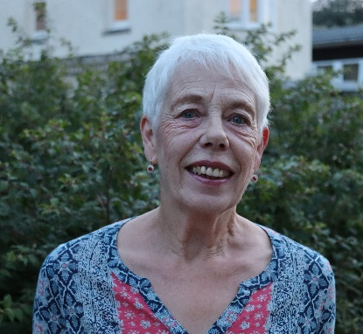
After completing my education at Larne Grammar School, I became a technician in the Quality Control Laboratories of Associated Animal Feed Manufactures in Belfast before relocating to Peterborough in 1973 with my husband and two young sons.

I joined the staff of Westwood House in January 1977 as Laboratory Technician. I have many happy memories, the lovely relaxing walk up the drive through all seasons, flapjack, or chocolate crunch at breaktime and the anticipation and fun of Appeals Day.

But the memory I treasure most from my thirty-three years is that I never felt that I was just a member of staff but a part of a happy school family.

